**Evaluating Management Strategies for Atlantic Bluefin Tuna**

***Report 3: Fitting operating models to data, MSE trial specifications and interactive visualization.***

February 2016

SHORT-TERM CONTRACT FOR MODELLING APPROACHES: SUPPORT TO BFT

ASSESSMENT (GBYP 02/2015) OF THE ATLANTIC-WIDE RESEARCH PROGRAMME ON

BLUEFIN TUNA (ICCAT-GBYP – Phase 5)

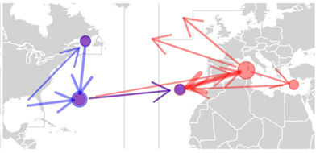

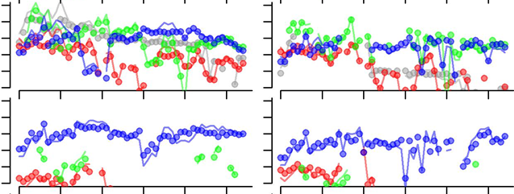

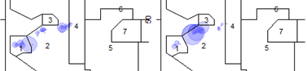

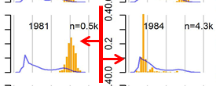

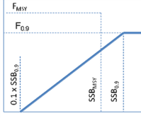

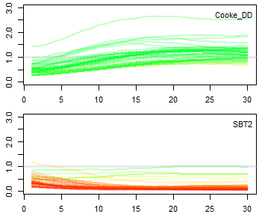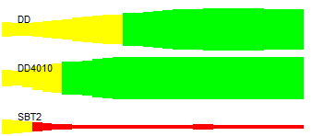

Tom Carruthers[1]

UBC

**Executive Summary**

I designed a theoretical framework for a multi-stock Atlantic bluefin tuna operating model. In addressing critical issues with previous multi-stock bluefin models, the design brief was simple: it should be fast, robust and use catch size composition data (does not require aging).

The equations for population dynamics, fishery dynamics and observation error models were presented in an SCRS paper at the bluefin species group meeting in September 2015 (Carruthers et al. 2015a, Report 2).

Based on these equations I developed a spatial, multi-stock statistical catch-at-length model in ADMB (modifiable multi-stock model, M3) that could be fitted to data.

A lack of validation was a principal concern with previous multi-stock models such as MAST. To validate the model, I developed a simulator in R. The simulator confirmed that the model was programmed correctly, provided relatively unbiased estimates of quantities of management interest and was used to establish correct data weightings.

A critical issue for conditioning operating models is (1) establishing what data have been collected to support fitting of operating models and (2) what data are most critical for conditioning operating models. To address #1, I constructed a metadata summary spreadsheet to identify all potential sources of data, the relevant people and the status of collaboration. I reached out and sent emails to all of the major data providers to illicit feedback and instigate collaboration. In most cases this was very positive. To address #2 I fitted the M3 operating model to simulated data to evaluate which sources are most critical to obtaining reliable estimates of quantities of management interest such as current stock size, stock depletion and sustainable fishing rates.

The metadata summary and the discussion of data priorities were also presented to the Bluefin species group meeting (September 2015) and summarized in an SCRS paper (Carruthers et al. 2015b; also included in Report 2).

A range of available electronic tagging, genetics and ICCAT catch, catch composition and CPUE data were formatted for use in conditioning the M3 model. This involved developing a standardized master relative abundance index from Japanese, Canadian and US CPUE data.

The M3 model was fitted to data and a series of R functions were developed for storing output data and plotting results and model fit.

The results of the preliminary fitted M3 model were presented to the Core Modelling Group (CMG) at the Monterey meeting in January 2016. Following feedback from the CMG, the M3 model was substantially updated to include age-specific movement rates and initialize the stock based on estimated fishing mortality rates.

I assisted Doug Butterworth and Rebecca Rademayer in the construction of a Trial Specifications document framing a prospective MSE for Atlantic bluefin tuna. This document served as the backbone for discussions of the CMG in Monterey.

In order to provide initial results to support the development of an online Shiny application, I used the commented Trial Specifications document to describe 192 operating models that were used in a demonstration MSE analysis. This MSE included 9 Management Procedures (MPs) developed in the previous contract. In addition I coded a new MP based on the harvest control rule of Cooke (2012).

The results of the preliminary MSE were used to develop an R Shiny application for investigating MSE results and performance metrics. The R Shiny application is intended as a proof of concept and included several features necessary for the presentation of complex results such as tabbed-panels dynamically linked to user-inputs.

This report also includes a summary of future data collection priorities (Section 7) and a progress report on the various project deliverables.

Contents

1 Introduction 4

1.1 Background 4

1.2 Progress following Report 2 (September 2015) 4

2 Fitting the M3 model to data 5

2.1 Constructing a relative abundance index for each spatio-temporal strata 6

2.2 Catch and catch composition data 8

2.3 Electronic tagging data 8

2.4 Stock of origin data 9

2.5 Model fit and issues arising 9

3 Modifications to the M3 model following the recommendations of the CMG 13

3.1 Spatial definition of areas 13

3.2 Age-specific movement 14

3.3 Model initialization 14

4 Trial specifications and preliminary MSE 14

4.1 Definition of trial specifications arising from Jan 2016 CMG meeting 14

4.2 Producing operating model definition files to represent trial specifications 15

4.3 Testing new management procedures 16

5 Results of preliminary MSE 17

6 Online interactive tools 18

7 Future priorities 20

7.1 Obtaining new spatial, age-structured data 20

7.2 Simulation test M3 operating model v1.17 20

7.3 Fit M3 to data 20

7.4 Finalize Trial Specifications and fit M3 model 20

7.5 Update online tools 20

7.6 Assist in experimental design of data collection programs 20

8 Progress with respect to deliverables 21

9 References 22

# Introduction

## Background

The Atlantic-Wide Research Programme on Bluefin Tuna (GBYP) aims to develop a new scientific management framework by improving data collection, knowledge of key biological and ecological processes, assessment models and management. A critical component of the GBYP is the construction of a robust advice framework consistent with the precautionary approach (GBYP 2014). A Management Strategy Evaluation (MSE, Cochrane 1998, Butterworth 1999, Kell et al. 2014, Punt et al. 2014) approach has been proposed to address this goal (Anon. 2014b). MSE establishes operating models that represent credible hypotheses for population and fishery dynamics which are used to quantify the efficacy of various management procedures. These management procedures may encompass a wide range of complexity from conventional stock assessments linked to harvest control rules (Hilborn 2003) through to simple empirical management procedures that calculate catch limits directly from resource monitoring data indices (Geromont and Butterworth 2014a;b, Kell et al. 2014).

MSE applications generally develop operating models from stock assessments that are fitted to data in order to ensure that model assumptions and estimated parameters are empirically credible (Punt et al. 2014, e.g. CCSBT 2011). In the case of Atlantic bluefin tuna, such a model requires enough complexity to capture the core uncertainties regarding Atlantic bluefin tuna dynamics (Fromentin et al. 2014, Leach et al. 2014). These include stock structure (Kell et al. 2012), stock mixing, migration (Fromentin and Lopuszanski 2014) and biases in observed data (e.g. annual catch data). Since operating models for Atlantic bluefin tuna must be able to represent hypotheses regarding spatio-temporal distribution and stock mixing (Kell et al. 2011, Arrizabalaga et al. 2014, Fromentin and Lopuszanski 2014) a suitable operating model must include spatial and seasonal structure.

## Progress following Report 2 (September 2015)

Report 2 summarized two SCRS papers that describe a spatial multi-stock operating model (the Modifiable Multi-stock Model, M3) that could be fitted to data to describe various scenarios for Atlantic bluefin population and fishery dynamics (Carruthers et al. 2015a) and the various data that have been collected to inform the operating model (Carruthers et al. 2015b). In this report I describe how the M3 model was fitted to preliminary fishery, genetics and electronic tagging data and highlight issues relevant to future model fitting (Section 2). These results were presented at the January 2016 meeting of the Core Modelling Group (Monterey, CA). The feedback from the group regarding appropriate model structure is included here in Section 3.

In addition to providing a progress report for this contract, a primary objective of the January 2016 meeting was establishing a preliminary set of operating models (Trial Specifications) for use in Atlantic bluefin MSE. These are summarized in a Trial Specifications document that describes the spatio-temporal strata of the operating model and the core axes of uncertainty over which to evaluate management procedures. A summary of the Trial Specifications is included in this report in Section 4.

A central recommendation of the CMG was the inclusion of age-specific movement rates. The M3 model code was updated to include these dynamics and the latest version (v0.17 is available on the private ICCAT Bluefin MSE GitHub site: https://github.com/iccat-mse). Since the data that are currently available are not disaggregated by age, it is not possible to fit this newer version of the M3 operating model. In the first contract the problem of insufficient data was circumvented by adding a feature to the MSE framework that would allow for operating models to be specified by user inputs. The user created an ‘operating model definition’ object which then creates various simulations. In order to meet the deliverables of this contract I chose to create operating model definition objects representing the trial specifications (since data were not available to inform the M3 model). In this way MSEs could be run and other coding and deliverables could be produced (e.g. Shiny Apps) without yet obtaining the fitted M3 models for each of the Trial Specifications. The results of these MSE runs is included in Section 5.

An online interactive application was developed using R Shiny to allow stakeholders to interact with outputs of the MSE. The application code is available on the private ICCAT GitHub site (https://github.com/iccat-mse) and the process and functionality are described in greater detail in Section 6.

A summary of progress with respect to contract deliverables is available in Section 8 and a list of priorities for future data, operating model development and collaboration are discussed in Section7.

# Fitting the M3 model to data

Following a simulation test of the M3 model (v0.15, Carruthers et al. 2015a) it was necessary to demonstrate that the model could be fitted to data that are currently available for Atlantic bluefin tuna. The critical sources of data are:

* A relative abundance index for each spatio-temporal strata (Section 2.1)
* Total catch by fleet for each spatio-temporal strata (Section 2.2)
* Catch composition data by each fleet (Section 2.3)
* Electronic tagging data (Section 2.4)
* Stock of origin data (Section 2.5)

The M3 model (v0.15) was fitted to quarterly data (Jan-Mar, Apr-Jun, Jul-Sep, Oct-Dec) for spatial areas defined by the bluefin tuna data preparatory workshop (2015, Figure 1).

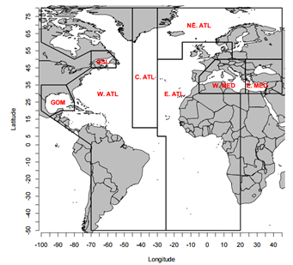

**Figure 1.** Spatial definitions agreed at the 2015 Atlantic bluefin tuna data preparatory workshop (Anon 2015).

A simple fleet structure based on gear group code was assumed for this preliminary fit to data. A four fleet model was fitted that included purse seine fishing (PS), trap fishing (TP), longline fishing (LL) and all other gear types combined (Other). The first three gear types encompass around 80% of all historical catches of Atlantic-wide bluefin tuna (Table 1, fleet structure B), however it misses an important fishery in the Eastern Atlantic (bait boat, BB: 9% of historical catches) and the Western Atlantic (rod and reel, RR: 21% of historical catches). Both are significant as the eastern fisheries extract many more tuna than the western fisheries (eastern BB is roughly 4 times that of western RR) and western RR is among the most important of the recent western fisheries. An alternative structure could be that of six fleets (type A) in Table 1.

**Table 1.** Contribution of fishing by gear groups to historical catches Atlantic-wide (top) and those assigned to Eastern (middle) and western stocks (bottom).



## Constructing a relative abundance index for each spatio-temporal strata

In the absence of an index derived from trip-level, fleet specific catch and effort data (a future data priority), a preliminary standardized index was derived from ICCAT Task II catch and effort data (ICCAT 2015) according to the following linear model:

(1) log(𝐶𝑃𝑈𝐸𝑦,𝑟,𝑚,𝑓) = 𝛼𝑦,𝑟 + 𝛽𝑚,𝑟 + 𝛿𝑓 + 𝜀

where *y*, *r*, *m* and *f* refer to years, areas, subyears and fleets, respectively.

The data of the Japanese longline, US longline and Canadian rod and reel fisheries were used to produce the standardized index because these offered the minimum number of fleet types that offered relatively complete spatio-temporal coverage (Figure 2).

Since the preliminary index is intended to represent relative abundance in time and space, the index was subject to smoothing using a simple 5-year moving mean approach to prevent unrealistic changes in inferred abundance among years (the non-smoothed index is presented in Figure 3a, Figure 3b shows the smoothed index).

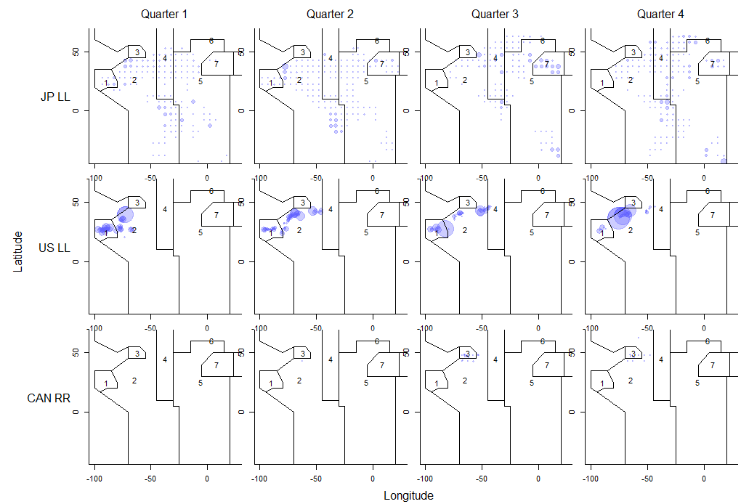

**Figure 2.** Spatiotemporal coverage of the Japanese longline, US longline and Canadian rod and reel fisheries (1960-2014). The area of plotted points is proportion to the mean catch rate.

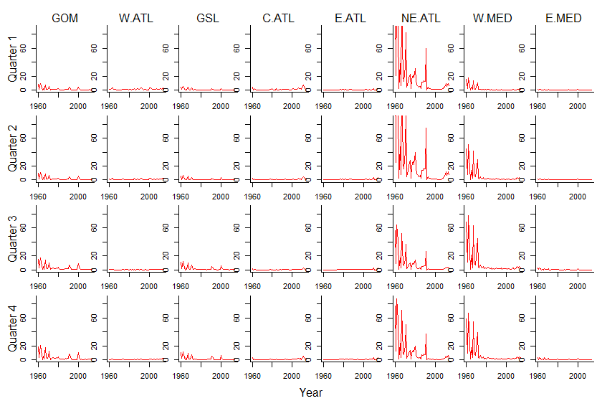

**Figure 3a**. Standardised preliminary relative abundance indices.

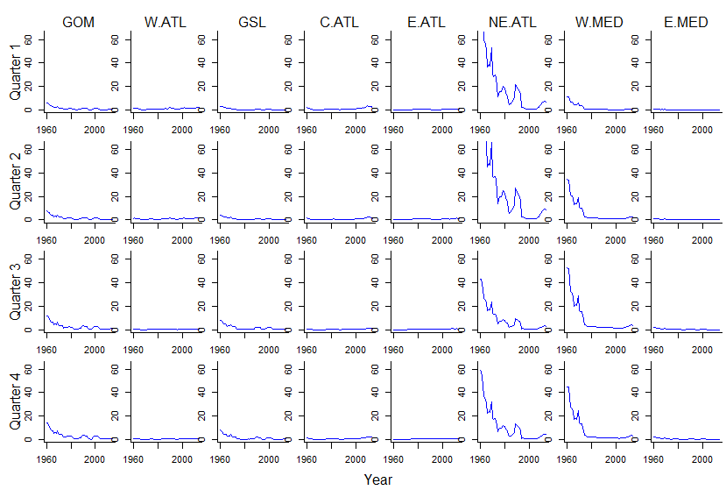

**Figure 3b**. Standardized preliminary relative abundance indices subject to smoothing by 5-year moving mean

## Catch and catch composition data

Catch data were assigned to spatio-temporal strata using the ICCAT Task II data that were uprated to annual Task I data by flag and gearcode. Catch composition data were also taken from the ICCAT website (‘Catch-at-size’: http://www.iccat.int/Data/CatSize/casBFT6009.rar).

## Electronic tagging data

A compiled electronic tagging dataset was provided by Matt Lauretta (US National Oceanic and Atmospheric Administration) that includes over 320 tags that record a total of 929 quarterly transitions. The dataset includes tags recaptured by GBYP tagging activities, the Canadian Department of Fisheries and Oceans, the Instituto Espanol de Oceanografia, the World Wildlife Fund, Azti, Unimar, the University of Cadiz.

Relative to the total number of PSAT and archival tags released on bluefin tuna these data are still rather limited and there are a number of important quarterly transitions for which there are no recorded recaptures (Figure 4).

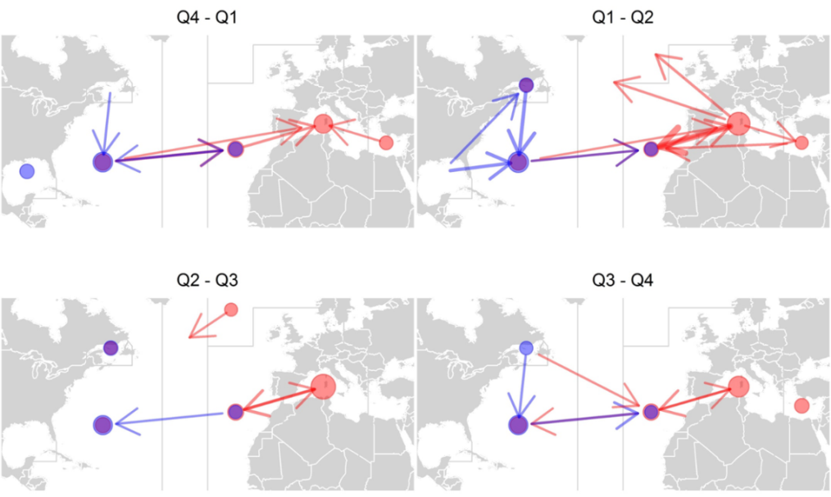

**Figure 4**. The quarterly transitions recorded by the current PSAT data. Circles denote tags that remained in that area, arrows denote movements. Red and blue colors refers to transitions of known eastern and western origin, respectively. The size of the point and the thickness of the arrow are proportional to the number of recorded transitions.

## Stock of origin data

The only stock of origin data provided to this preliminary model came from AZTI and the University of Maryland. These stock of origin data were however not complete across all quarters and areas (Table 2).

**Table 2.** Available stock of origin data (otolith microchemistry) and pertinent gaps (shaded orange). Numbers represent the number of fish identified.

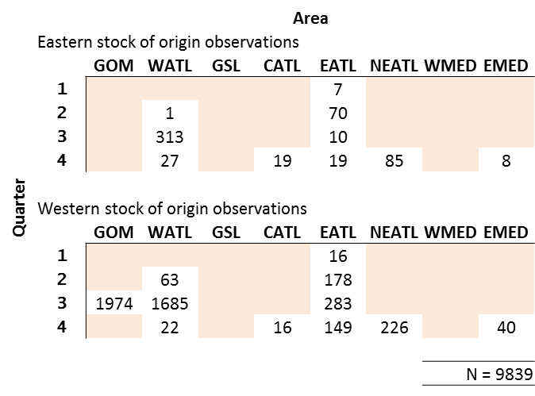

## Model fit and issues arising

The motivation behind fitting the M3 model to preliminary data was to reveal potential areas of model misspecification but primarily to highlight that much work is still required to process data and finalize the appropriate fleet structure.

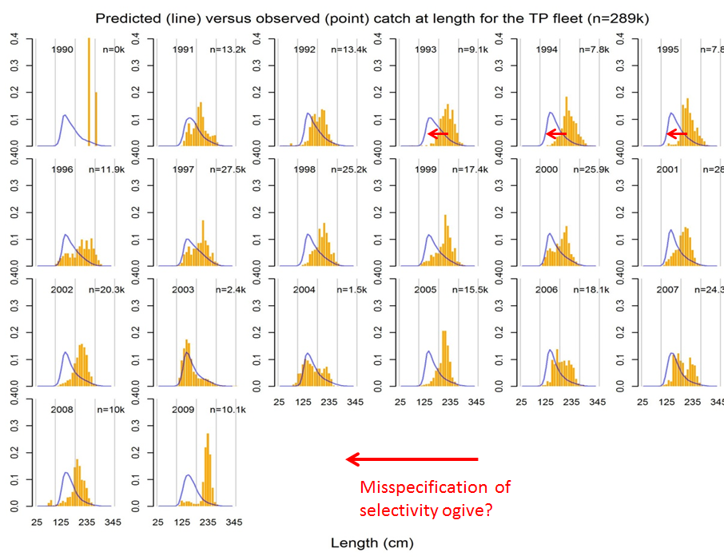

**Figure 5a.** Preliminary M3 model fit to the trap fleet.

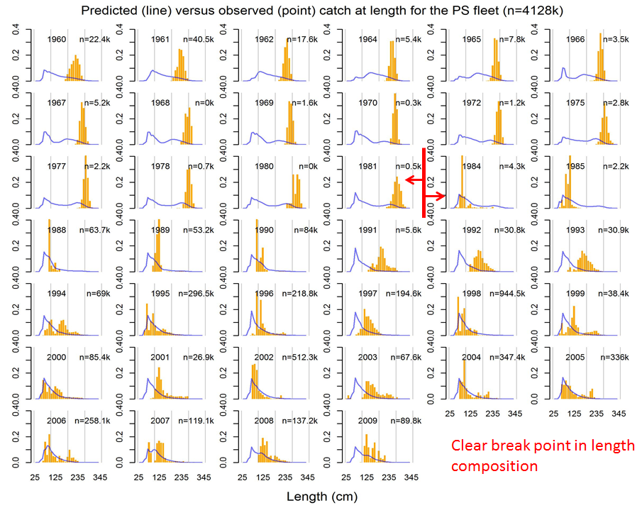

**Figure 5b.** Preliminary M3 model fit to the purse seine fleet.

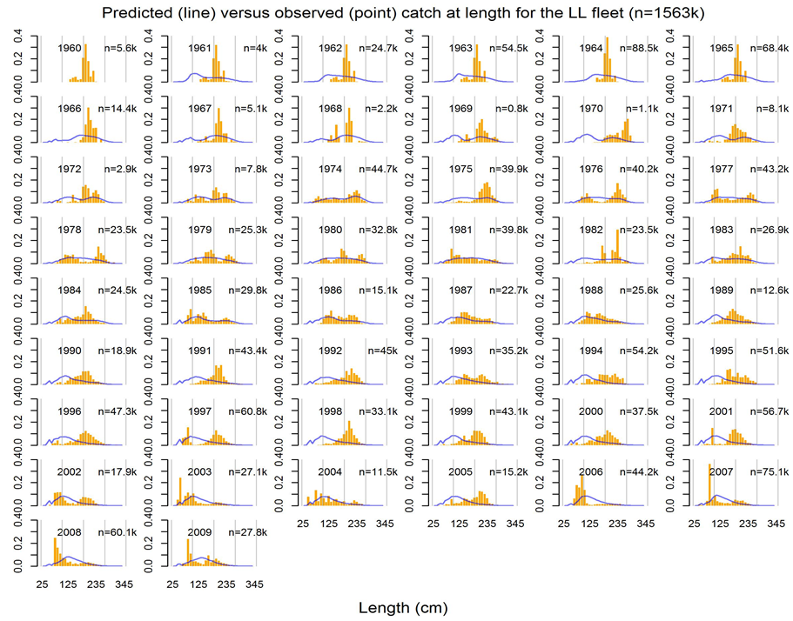

**Figure 5c.** Preliminary M3 model fit to the longline fleet.

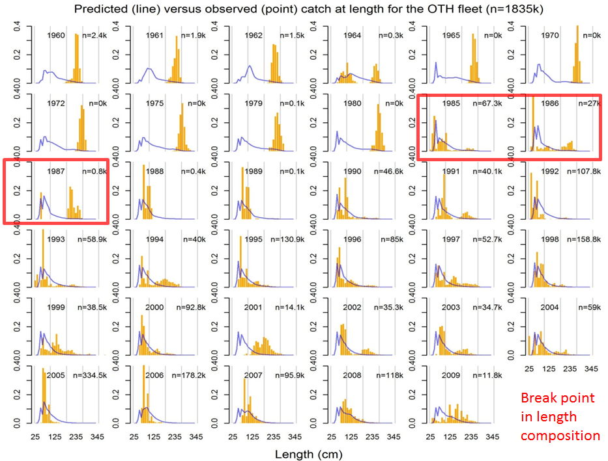

**Figure 5d.** Preliminary M3 model fit to the ‘other’ fleet.

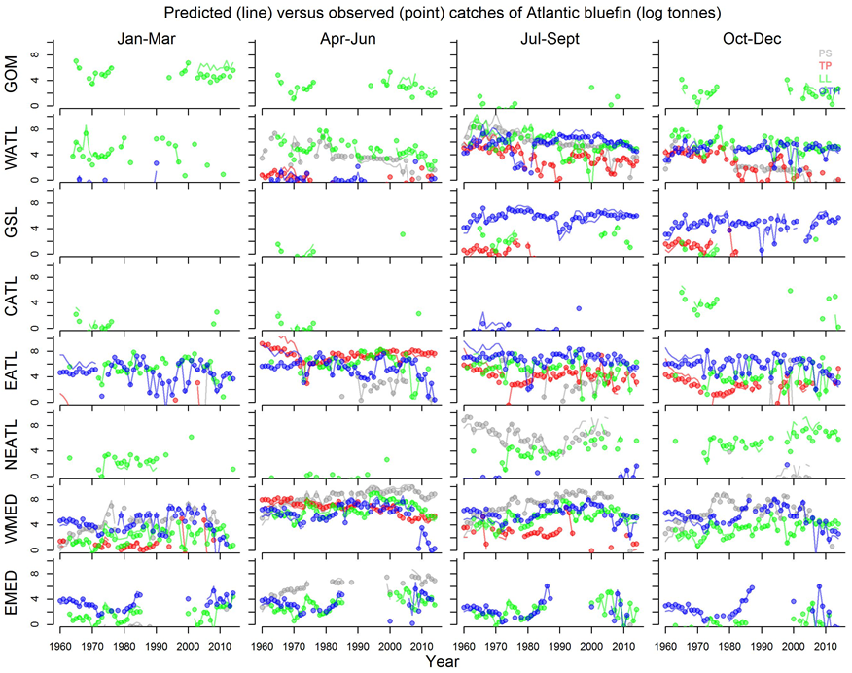

**Figure 6a**. Fit to log catches (mt) by fleet type year and quarter.

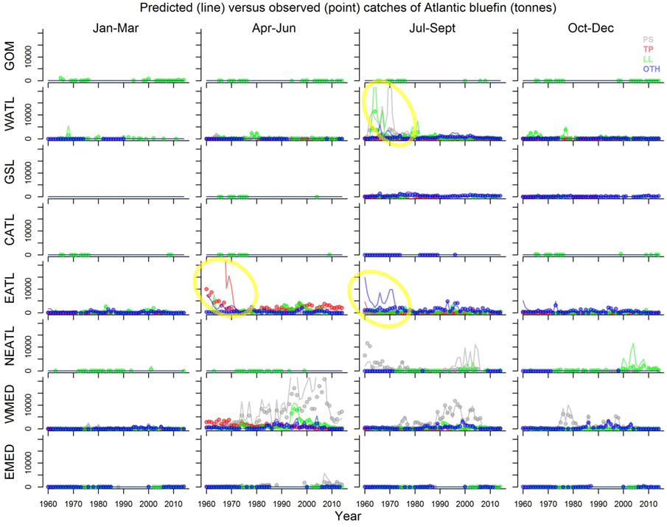

**Figure 6b.** Fit to catches (mt) by fleet type year and quarter. Yellow circles highlight areas of significant model misfit.

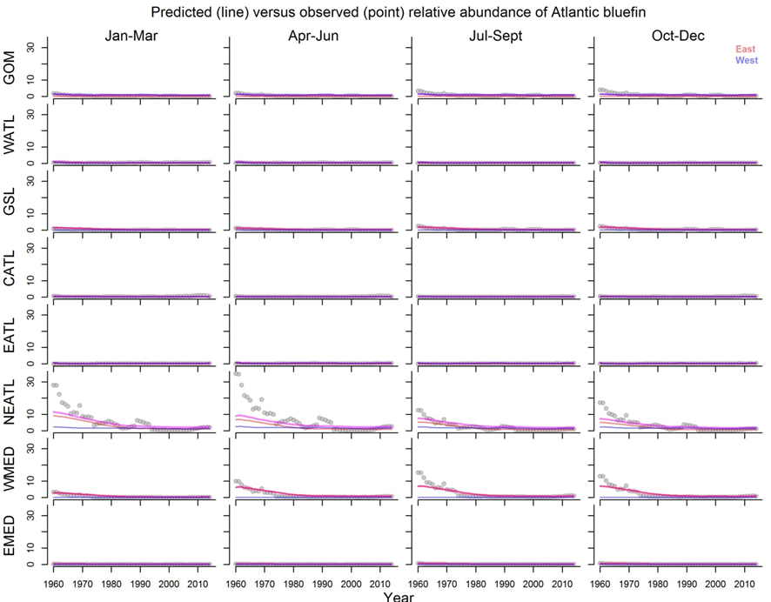

**Figure 7.** Model fit to relative abundance indices.

Preliminary model fitting reveals that the model can approximate trends in exploitation (Figure 6a) and the spatio-temporal distribution of the stock (Figure 7). However there are significant areas for improvement, particularly in the definition of fleet types. There are, for example, clear temporal breaks in the size composition of catches for the purse seine (Figure 5b) and ‘other’ fleets (Figure 5c). There is also a general inability for the model to track the steep inferred declines in abundance over the early period (Figure 7) despite strongly over estimating catches during that period (6b).

# Modifications to the M3 model following the recommendations of the CMG

At the Jan 2016 meeting of the CMG (Monterey) a number of changes to operating model structure and assumptions were recommended including a change in spatial structure, an alternative approach for initializing the model in the initial model year (1960), a requirement to account for age-specific movement and a lag in stock recruitment. These changes were made to M3 version 1.15, the new up-to-date version 1.17 is available on the ICCAT GitHUB site (https://github.com/iccat-mse). Note however that this model is no longer compatible with the data that were used to demonstrate preliminary model fitting (Section 2) since the new model (v1.17) requires electronic tagging and stock of origin data disaggregated by age class.

## Spatial definition of areas

It was decided that the 8 area model first discussed at the 2015 data preparatory meeting (Figure 9, panel b) should be replaced with an 11 area model (Figure 8, panel a) that could better represent western stock structure and account for recent shifts in the distribution of Japanese longline effort in the Central North Atlantic. The increased spatial resolution increases model running time by around 20%.

(b)

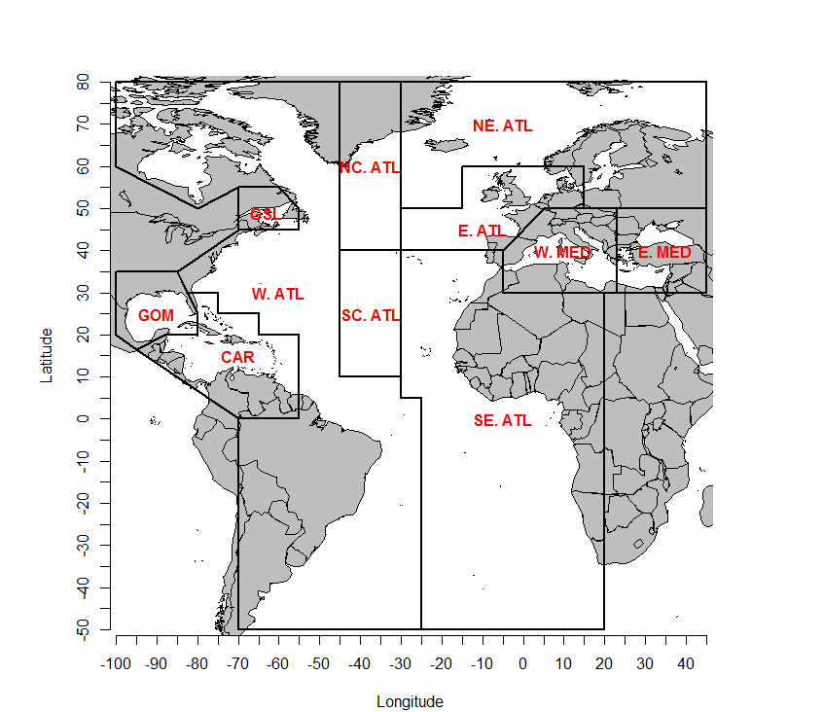

(a)

**Figure 8.** Spatial definitions agreed at the 2016 CMG (a) and those discussed at the 2015 Atlantic bluefin tuna data preparatory workshop (b).

## Age-specific movement

Since age-specific electronic tagging and stock of origin data are currently not available M3 v1.15 did not attempt to estimate age-specific movement. The CMG concluded that these are important dynamics to capture. The CMG identified three movement age groups: ages 0-2, 3-8, 9+. The primary objective of these age groups is to approximate the higher levels of mixing of intermediate age classes (3-8). These changes have subsequently been built into the latest version of M3 (v1.17) but data are not yet available to support estimation.

## Model initialization

M3 v1.15 initialized the model at a user-specified level of stock depletion. The CMG expressed a preference for an approach that initializes stock biomass and distribution according to equilibrium conditions given average fishing rates over the first five model years (1960-1964). This is solved numerically by iteratively running the model for a number of ‘years’. While this is more computationally intensive (typically running time is around 20% more per iteration), it is more appropriate for approximating the distribution of fish subject to age-specific movement for which there is no straightforward analytical solution.

# Trial specifications and preliminary MSE

A draft trial specification document was lead authored by Doug Butterworth that followed a similar format to those established in MSEs for Southern Bluefin Tuna and the International Whaling Commission. The trial specifications document includes a detailed description of the operating model structure, the data on which the operating model is conditioned and the various factors over which uncertainty in stock dynamics are to be explored, including factor levels for each factor (e.g. high, medium and low natural mortality rate).

## Definition of trial specifications arising from Jan 2016 CMG meeting

The specification of operating models was divided into a reference set and a robustness set. The reference set represents plausible alternative hypotheses for stock and fishery dynamics with respect to three axes of uncertainty: (1) future stock recruitment relationship, (2) the starting level of stock abundance and (3) the combination of natural mortality rate and age at maturity (see Table 3 for the proposed levels for each of these axes).

**Table 3**. Reference operating model set.

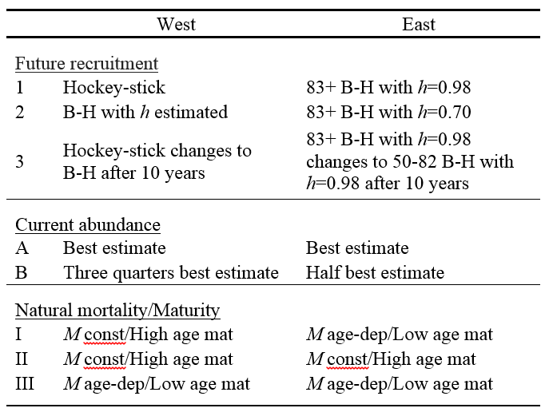

The proposed robustness set represents less credible hypotheses for stock and fishery dynamics. These operating models a single factor variant on each of two scenarios from the Reference Set: [1,A, I] and [2, A, I]

i. Future recruitment change as in 3), but with prob of 0.05 for each of the first 20 years of projection

ii. Unrealised overcatches each year of [X] tons in the West and [Y] tons in the East+Med

iii. Use of alternative indices [to be specified] in the MP

iv. Alternative combinations of fleets in evaluating selectivities for the operating models

v. An undetected increase in catchability for CPUE-based abundance indices of 1% per annum

vi. Alternative assignments to stock of origin of historical catches from the South Atlantic

## Producing operating model definition files to represent trial specifications

In the first contract (GBYP 02/2014, ICCAT-GBYP – Phase 4) the MSE framework was developed and demonstrated without access to an operating model that had been conditioned on the data (ICCAT 2014). This was achieved by creating operating model definition objects (OMd) that the user can specify to generate simulations consistent with stock and fishery hypotheses (e.g. low natural mortality rate, low stock levels relative to unfished etc). The same approach was taken here and operating model definition objects were defined that approximated the reference and robustness sets. This allowed for the testing of a new management procedure (Section 4.3) and the development of an online interactive tool for presenting MSE outputs and concepts (Section 6) (see Figure 9).

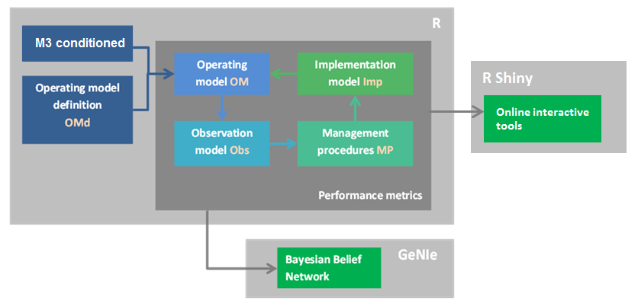

**Figure 9.** Diagram demonstrating how MSE software development can proceed in the absence of a conditioned operating model using operating model definition objects (OMd).

## Testing new management procedures

The preliminary MSE included the MPs of the previous simulation exercise and that of Cooke (2012). The Cooke MP states that an assessment is undertaken and a harvest control rule imposed such that fishing is constant at F0.9 (fishing mortality rate below FMSY where yields are 90% FMSY, Y0.9) where the stock is at or above SSB0.9 (equilibrium biomass subject to F0.9). At stock levels below SSB0.9 fishing rate follows a linear decline from F0.9 to zero where stock levels are at 10% of SSB0.9, below which, fishing rate is set to zero (Figure 10).

To emulate this approach I used a delay-difference assessment to estimate FMSY and SSBMSY. It is too computationally intensive to undertake the optimization to find F0.9 every instance that the management procedure is applied (i.e. for each simulation for each future management update). However under a wide range of simulated conditions SSB0.9 was close to 25% larger than SSBMSY. This was used as a proxy for SSB0.9. Since Y0.9 is by definition 90% of MSY, a suitable proxy for F0.9 = FMSY*0.9/1.25 = 0.72FMSY. This management procedure ‘Cooke_DD’ is similar to the existing management procedure DD_4010 that uses a 40-10 harvest control rule.

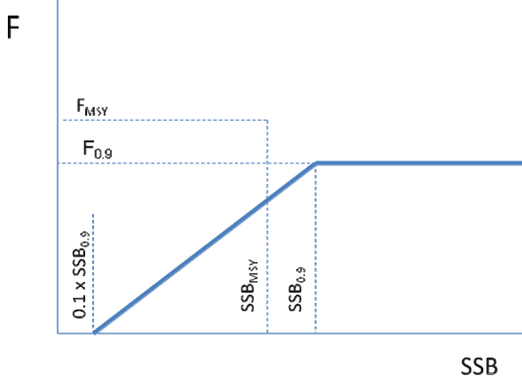

**Figure 10.** The harvest control rule of Cooke (2012).

# Results of preliminary MSE

For the eastern stock, the results of the preliminary MSE runs can be investigated using the interactive R Shiny application (Section 6, below).

In general the combined natural mortality rate /age-at-maturity axis of uncertainty was the most influential determinant of performance, specifically the II (high age-at-maturity both stocks) and III (low age-at-maturity both stocks) scenarios of Table 3. The result that lower age-at-maturity should lead to higher risks of overfishing and overfished state may be counter-intuitive to some readers (see Corriero et al. 2005). In these simulations the user specifies depletion (much like fitting to an index) and the operating model finds a schedule of fishing that matches that depletion given the maturity-at-age schedule. It follows that fishing mortality rates must be historically much higher for low age-at-maturity fisheries to obtain similar depletion levels. These stocks are also estimated to be more productive and smaller. The result is higher likelihoods of overfishing fishing under projections and lower absolute yields under rebuilding.

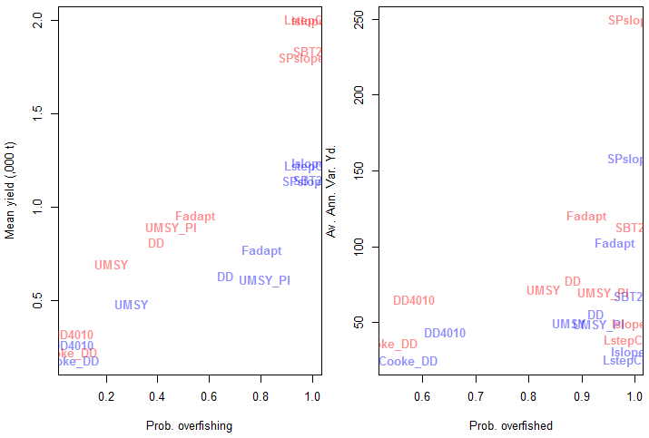

**Figure 11**. Performance trade-offs for management procedures among high age-at-maturity (red) (II, Table 3) and low age-at-maturity (blue) (III, Table 3) scenarios.

The Cooke_DD management procedure performed similarly to the delay-difference model but was generally somewhat more biologically precautionary leading to lower yields and lower probabilities of overfishing. The Cooke_DD MP also provided very low interannual variability in yield, compared with most of the other MPs.

Worm plots however, show that the low age-at-maturity scenario is likely to rebuild stocks above 50% BMSY more often (Figure 12). For example the Fadapt and Delay Difference (DD) MPs. Interestingly, fishing at harvest rate at MSY with perfect information (UMSY_PI) leads to relatively slow rebuilding compared with some other MPs indicating that rebuilding may require fishing rates substantially below FMSY. Generic MPs SPslope, Islope1, LstepCC4 and the SBT2 MPs had very low likelihoods of rebuilding stocks above half of BMSY (Figure 12).

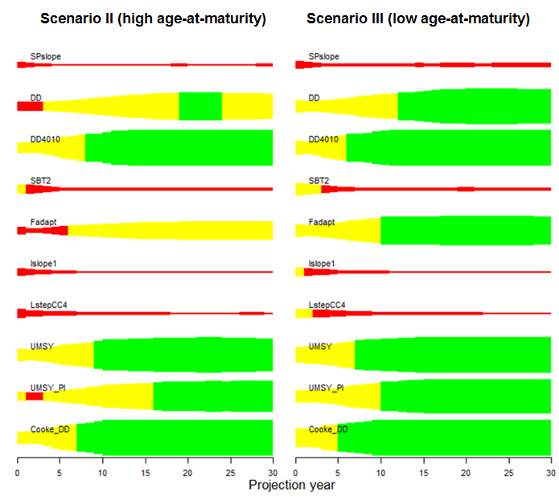

**Figure 12.** Worm plots illustrating the probability of the simulated stock being above 50% BMSY over the 30 year projection. Red segments are years in which less than 25% of simulations had biomass above 50% BMSY and green segments are years in which over 75% of simulations had biomass above 50% BMSY.

# Online interactive tools

An R Shiny application was developed to demonstrate how MSE results could be communicated to a wider audience (Figure 13). At the centre of the application are two user defined sets of operating models. The user can modify operating model assumptions and examine how these affect performance trade-offs among management procedures, biomass trajectories and the likelihood of reaching biomass targets (worm plots).

The principal objective of the application is to generate interest in these tools and obtain feedback from the CMG about appropriate detail and context for such a tool.

The R Shiny app features:

* Detailed operating model specification / comparison
* Multi panel tab window
* Dynamic control panel
* Default switches for loading standard operating model sets
* Trade-off plots with user -pecified performance metrics
* Projection plots with user-specified management procedures
* Work plots with user-specified target biomass and thresholds

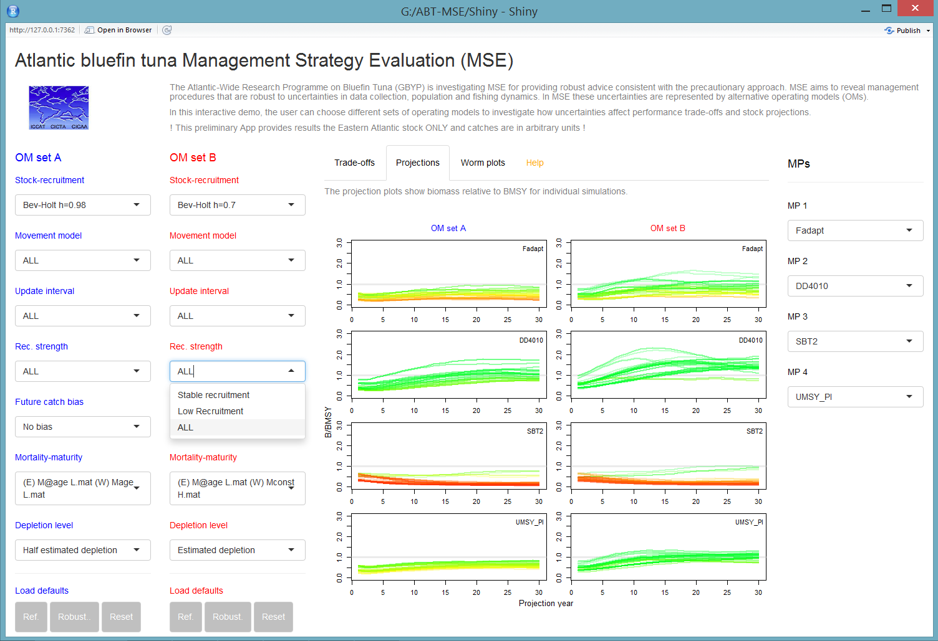

**Figure 13**. A screenshot from the ABT-MSE shiny app.

# Future priorities

## Obtaining new spatial, age-structured data

Following the recommendation of the CMG to estimate age-based movement over newly defined spatial areas (11 areas, Figure 8 panel a), it is a priority to obtain data at that spatial resolution and to obtain electronic tagging data and stock of origin data by age class. Carruthers et al 2015b provide detail on the most important data for conditioning operating models. In summary, these are (by 11 area model, quarter):

* Stock of origin by age class (e.g. otolith microchemistry, Drs Rooker and Secor)
* Electronic tagging by age class (e.g. PSAT data, Drs Lauretta, Block and Lutcavage)
* A joint standardized CPUE index (e.g. combining Hanke et al. 2015, Kimoto et al 2015a,b, Lauretta and Brown 2015, and Walter 2015)
* An inverse age-length key (probability of a length class given age) preferably by year
* Finalized indices of spawning stock biomass by stock (e.g. Ingram et al. 2015)

An additional priority are analyses to identify the correct fleet disaggregation (time and gear type) for M3 model fitting.

## Simulation test M3 operating model v1.17

The new age-based movement estimator requires simulation testing to identify coding errors, possible biases and correct weighting of various data sources.

## Fit M3 to data

The M3 model should be fitted to the data of 8.1 as soon as possible. This process allows model fit to be evaluated which can indicate model misspecification or necessary changes in fleet structure.

## Finalize Trial Specifications and fit M3 model

Once a base-case model is fitted to data alternative model fits can be carried out that represent the Trial Specifications document.

## Update online tools

After incorporating feedback on the R Shiny application produced in this contract, the new MSE results can be incorporated in an updated application.

## Assist in experimental design of data collection programs

A number of proposed data collection programs require simulation testing to identify suitable experimental designs. These include estimation of stock biomass using close-kin genetics tagging (e.g. Bravington et al. 2013) and gene tagging. The MSE framework can also be used to quantify value of information of current data collection programs.

# Progress with respect to deliverables

**8.1 The deliverables include documented, object-oriented SC4 Classes and C++ source code for the Operating Model (OM), including the Observation Error Model, (OEM) that can be used by third parties to develop and evaluate their own Management Procedures (MPs) consistent with the recommendations of the Modelling Coordinator, ICCAT population dynamics specialist and Modelling Steering Group. All code shall be available at the** [**https://github.com/iccat-mse**](https://github.com/iccat-mse) **and** [**https://github.com/generic-mse**](https://github.com/generic-mse) **github repositories.**

[100%] The latest version of the ADMB M3 operating model (v0.17) including changes suggested at the CMG (Monterey Jan 2016) is available on the ICCAT GitHub site.

**8.2 Based on the review of population hypotheses and stock structure, provide OM classes that can be used to conduct sensitivity analyses and then to implement hypotheses in the OM in order to evaluate alternative OEMs and MPs. *Specific outcome:* Provide examples for the review paper on population hypotheses and stock assumptions (see SCRS, 2013).**

[100%] Operating model definition files were created that match Trial Specifications document finalized at the Jan 2016 CMG in Monterey. Operating model definition files for the review paper are already available from the previous contract that can be used to provide examples for the review paper on population hypotheses and stock assumptions (GBYP 02/2014, ICCAT-GBYP – Phase 4).

**8.3 Develop the Observation Error Model (OEM) that can be used to evaluate different data collection regimes e.g. aerial surveys, tagging programmes, catch and catch per unit effort (CPUE) and size to age conversions. *Specific outcome:* Use the OEM to conduct an analysis to show how improving data and knowledge can be used to reduce uncertainty and write up as an SCRS paper or peer review manuscript.**

[100%] Observation models were developed and coded in the fitting of the M3 model to data. The simulation testing of the M3 operating model also required the simulation of these observation processes.

**8.4 Use the OM to evaluate alternative MPs developed and proposed by third parties. This requires to have a least one example of an MSE that evaluates a MP proposed by members of SCRS (e.g. Cooke, 2012). *Specific outcome:* Participate in manuscript, i.e. an SCRS or peer review paper, that documents the example(s).**

[100%] The MSE framework was updated to include the harvest control rule of Cooke 2012. No other MPs or harvest control rules have been suggested but the MSE framework is now compatible with over 60 new MPs coded in the R package DLMtool (Carruthers and Hordyk 2014).

**8.5 Develop interactive tools in collaboration with other RFMOs for use with stakeholders based on Shiny (e.g.** [**http://shiny.iphc.int/sample-apps/shiny/**](http://shiny.iphc.int/sample-apps/shiny/)**). *Specific outcome:* Published the interactive tool at** [**http://rscloud.iccat.int:3838/bft-mse/**](http://rscloud.iccat.int:3838/bft-mse/)

[100%] The shiny app has been uploaded to the ICCAT GitHub site (ABT-MSE/Shiny/)

**Acknowledgments**

Many thanks to my coauthors of the two SCRS papers (Carruthers et al. 2015a;b) that supported this work: Ai Kimoto, Matt Lauretta, Toshihide Kitakado, Doug Butterworth, Joe Powers, Laurie Kell, and Antonio Di Natale. This work was carried out under the provision of the ICCAT Atlantic-Wide Research Programme for Bluefin Tuna (GBYP), funded by the European Union, by several ICCAT CPCs, the ICCAT Secretariat and by other entities (see:http://www.iccat.int/GBYP/en/Budget.htm). The content of this paper does not necessarily reflect the point of view of ICCAT or of the other funders, which have no responsibility for it, neither does it necessarily reflect the views of the funders and in no way anticipates the Commission's future policy in this area.

# References

Anon. 2015. Report of the 2015 ICCAT bluefin data preparatory meeting (Madrid, Spain - March 2-6, 2015).

Arrizabalaga, H., Fromentin, J.M., Kell, L.T., Kerr, L.A., Kimoto, A., Porch, C., Secor, D.H. 2014. Population hypotheses and stock assumptions for North Atlantic Bluefin tuna. SCRS/2014/xxx.

Block, B., A., Teo, S.L.H., Walli, A., Boustany, A., Stokesbury, M.J.W., Farwell, C.J., Weng, K.C., Heidi, D., Williams, T.D. 2005. Electronic tagging and population structure of Atlantic bluefin tuna. Nature. 434: 1121-1127.

Bravington, M. V., Grewe, P.G., Davies, C.R. 2013. Fishery-independent estimate of spawning biomass of Southern Bluefin Tuna through identification of close-kin using genetic markers. FRDC Report 2007/034. CSIRO, Australia.

Butterworth, D.S., Punt, A.E., 1999. Experiences in the evaluation and implementation of management procedures. ICES J. Mar. Sci. 56, 985-998.

CCSBT. 2011. Report of the Sixteenth Meeting of the Scientific Committee. Bali, Indonesia. Commission for the Conservation of Southern Bluefin Tuna. Available at: <http://www.ccsbt.org/userfiles/file/docs_english/meetings/meeting_reports/ccsbt_18/report_of_SC16.pdf>

Cochrane, K L., Butterworth, D.S., De Oliveira, J.A.A., Roel, B.A., 1998. Management procedures in a fishery based on highly variable stocks and with conflicting objectives: experiences in the South African pelagic fishery. Rev. Fish. Biol. Fisher. 8, 177-214.

Cooke, J.G. 2012. Outline of a candidate management procedure for Atlantic Bluefin tuna. Col. Vol. Sci. Pap. 68(10): 312-318.

Corriero, A., Karakulak, S., Santamaria, N., Deflorio, M., Spedicato, D., Addis, P., Desantis, S., Cirillo, F., FenechFarrugia, A., Vassallo-Agius, R., de la Serna, J. M., Oray, Y., Cau, A., Megalofonou, P., Metrio, G., 2005. Size and age at sexual maturity of female bluefin tuna (*Thunnus* *thynnus* L. 1758) from the Mediterranean Sea. Journal of Applied Ichthyology 21, 483–486.

Fromentin, J-M., Lopuszanski, D. 2014. Migration, residency and homing of Bluefin tuna in the western Mediterranean Sea. ICES J. Mar. Sci. 71(3): 510-518.

Fromentin, J-M., Bonhommeau, S., Arrizabalaga, H., Kell, L.T. 2014. The spectre of uncertainty in management of exploited fish stocks: the illustrative case of Atlantic bluefin tuna. Mar. Pol. 47:8-14.

GBYP. 2014. ICCAT Atlantic wide research programme for Bluefin Tuna. Available online at: <http://www.iccat.int/GBYP/en/index.htm> [accessed October 2014]

Geromont, H.F., Butterworth, D.S. 2014a. Generic management procedures for data-poor fisheries; forecasting with few data. ICES J. Mar. Sci. doi:10.1093/icesjms/fst232.

Geromont, H.F., Butterworth, D.S. 2014b. Complex assessments or simple management procedures for efficient fisheries management: a comparative study. ICES J. Mar. Sci. doi:10.1093/icesjms/fsu017.

Hanke, A.R., Andrushchenko, I., Whelan, C. 2015. Indices of stock status from the Canadian bluefin tuna fishery:1981 to 2013. ICCAT, Col. Vol. Sci. Pap., 71(2): 983-1017.

ICCAT 2014. Report of the 1st Meeting of ICCAT GBYP Core Modelling Group. Available at: <http://www.iccat.int/GBYP/Documents/MODELLING/PHASE%204/BFTMSE_CMG1_Report.pdf> [accessed September 2015]

ICCAT 2015. Information published on TaskII – Catch and Effort (T2CE). Available at: <https://www.iccat.int/Data/t2ce-ENG.pdf> [accessed September 2015]

Ingram, G.W., Jr., D. Alvarez-Berastegui, P. Reglero, R. Balbín, A. García5, and F. 2015. Alemany. Indices of larval bluefin tuna (Thunnus thynnus) in the Western Mediterranean Sea (2001-2013). SCRS/2015/035.

Kell, L.T., Kell, A.A. 2011. A comparison of age slicing and statistical age estimation for Mediterranean swordfish (*Xiphias gladius).* ICCAT, Col. Vol. Sci. Pap., 66(4): 1522-1534.

Kell, L.T. T., Fromentin, J.-M., Bonhommeau, S. 2011. An Evaluation of the Implications of Population Structure on the Current Bluefin Tuna Advice Framework. SCRS/2011/110.

Kell, L.T. T., Fromentin, J.-M., Bonhommeau, S. 2012. An Evaluation of the Implications of Population Structure on the Current Bluefin Tuna Advice Framework. ICCAT, Col. Vol. Sci. Pap., 68(1): 370-378

Kell, L.T., Hillary, R., Fromentin, J.-M., Bonhommeau, S. 2014. An example management strategy evaluation of a model free harvest control rule. ICCAT, Col. Vol. Sci. Pap., 71(6): 2790-2797.

Kimoto, A., Takeuchi, Y., Itoh, T. 2015a. Updated standardized bluefin CPUE from the Japanese longline fishery in the Atlantic to 2014 fishing year. ICCAT, Col. Vol. Sci. Pap., 71(2): 1059-1097.

Kimoto, A., Takeuchi, T., Itoh, T. 2015b. Discussion on the area stratification in the North Atlantic for bluefin tuna mixing model. SCRS/2015/172.

Lauretta, M.V., Brown, C.A. 2015. Standardized catch rates of bluefin tuna (*Thunnus thynnus*) from the rod and reel/handline fishery off the northeast United States during 1993-2013. ICCAT, Col. Vol. Sci. Pap., 71(3): 1223-1237.

Leach, A.W., Levontin, P., Holt, J., Kell, L.T., Mumford, J.D. 2014. Identification and prioritization of uncertainties for management of Eastern Atlantic bluefin tuna (*Thunnus thynnus*).

Lutcavage, M.E., Galuardi, B., Lam, T.C.H. 2012. Predicting potential Atlantic spawning grounds of western Atlantic bluefin tuna based on electronic tagging results, 2002-2011. Col. Vol. Sci. Pap. ICCAT. 69(2): 955-961.

Punt, A.E., Butterworth, D.S., de Moore, C. L., De Oliveira, J. A. A., Haddon, M. 2014. Management strategy evaluation: best practices. Fish and Fisheries. doi: 10.1111/faf.12104

1. [t.carruthers@oceans.ubc.ca](mailto:t.carruthers@oceans.ubc.ca) 335 IOF, 2202 Main Mall, UBC V6T 1Z4 +1 604 822-6903